**Question 1:** 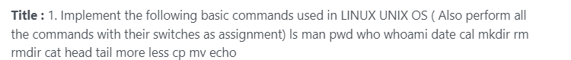

**Answer:**

ls command



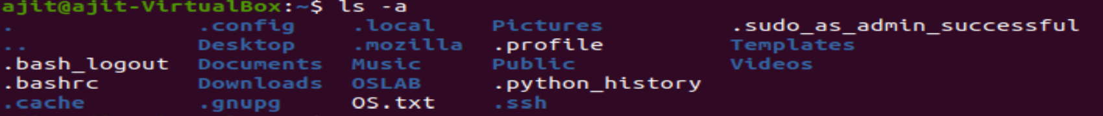

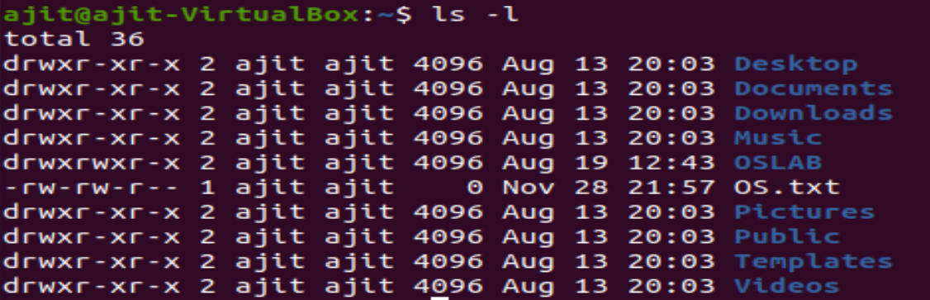



man command



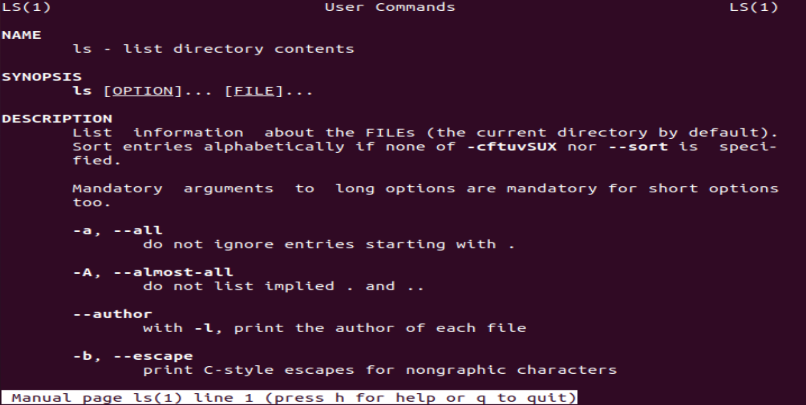

pwd command

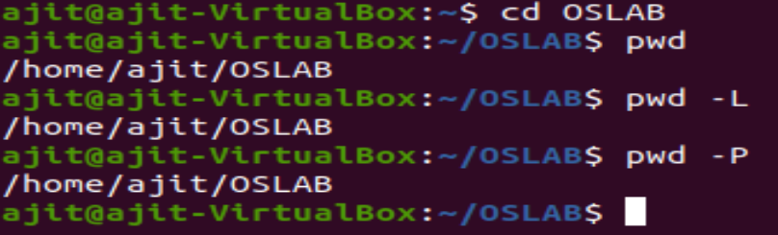

who command

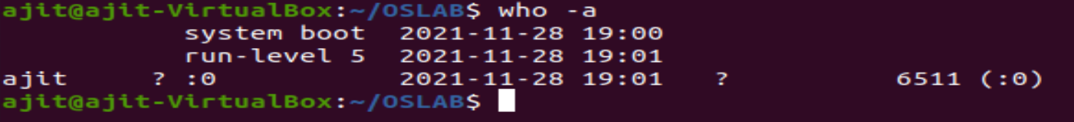



whoami command

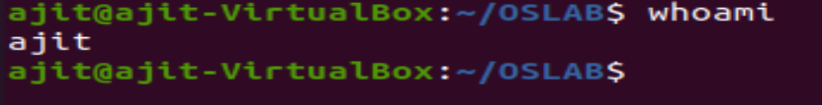

date command

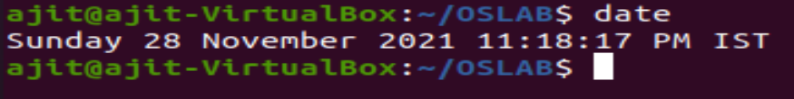

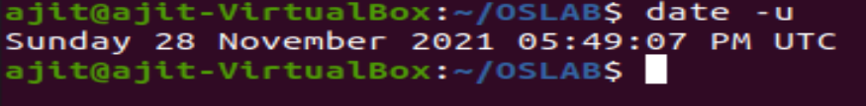





cal command

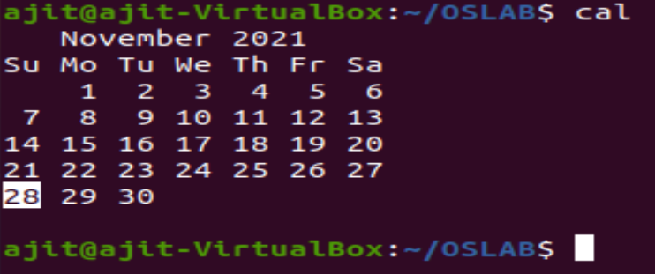

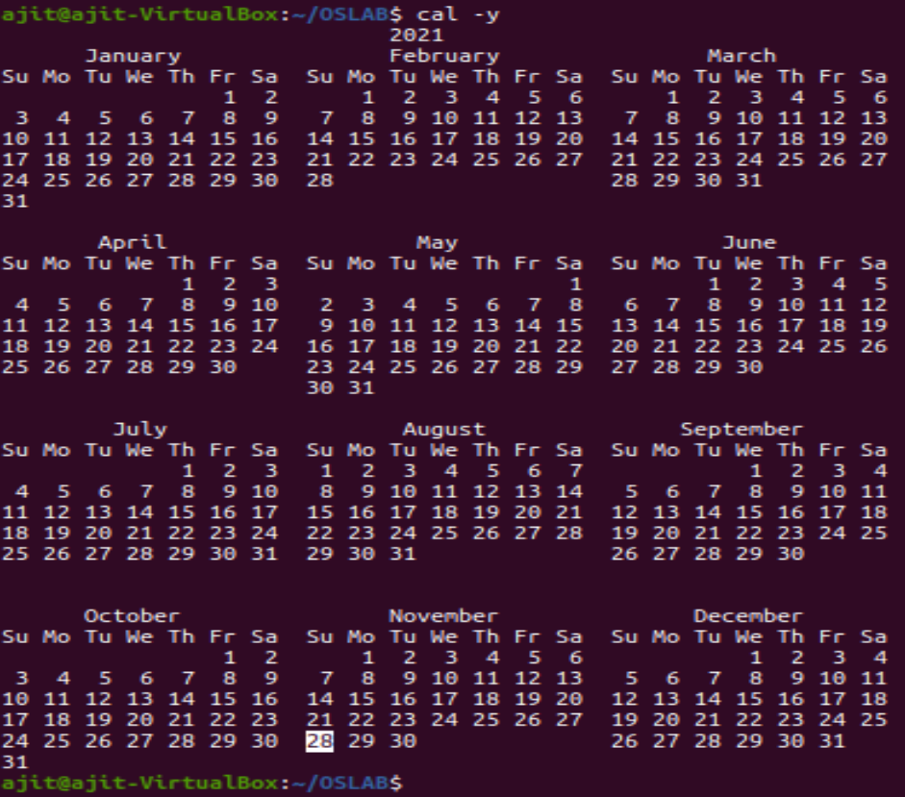

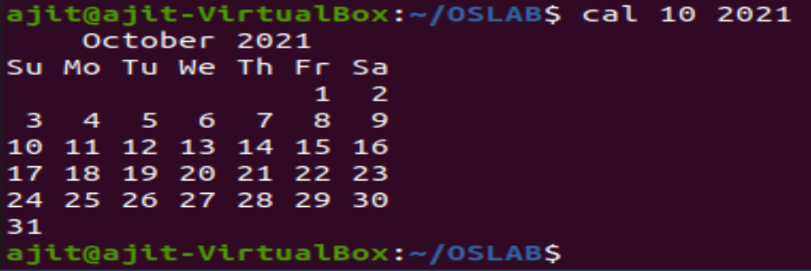

mkdir command

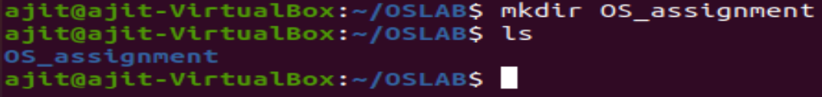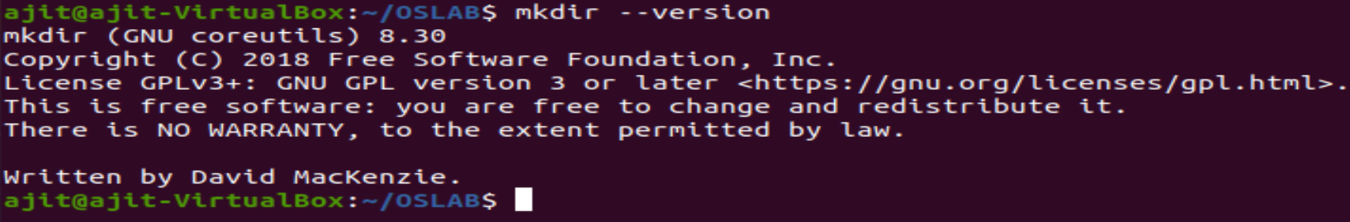

rm command

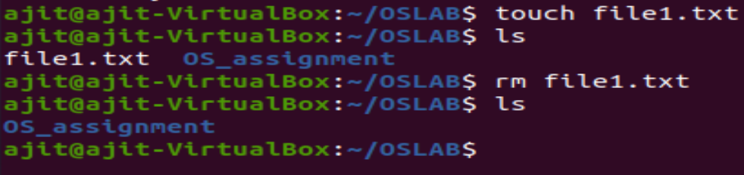

rmdir command

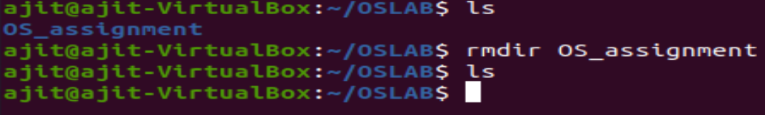

cat command

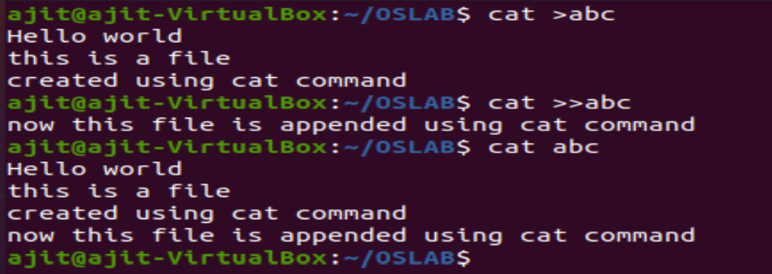

head command

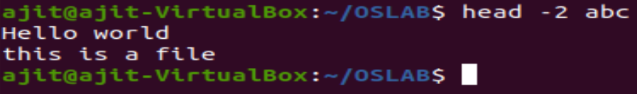



tail command

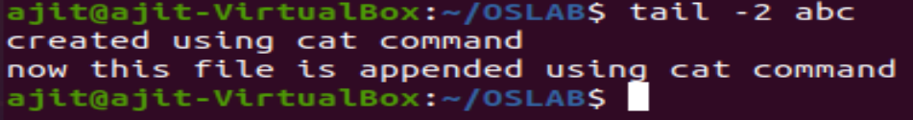

head and tail command





more command

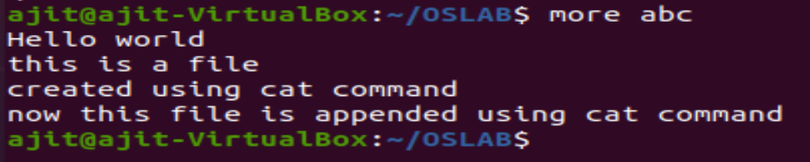

Less command



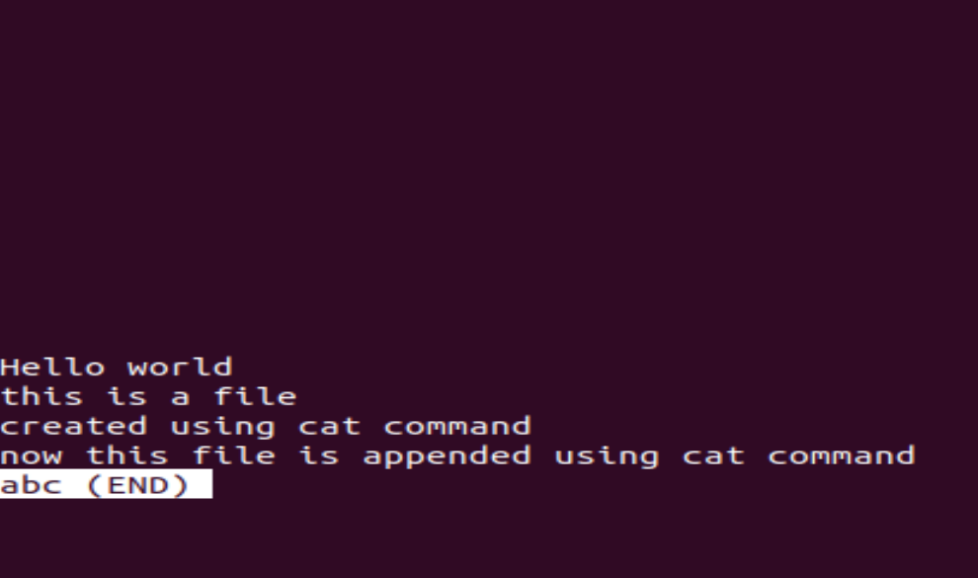

cp command

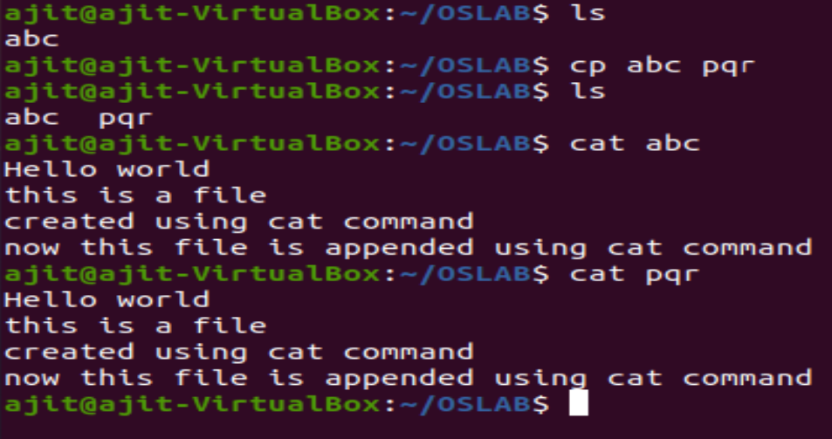

mv command

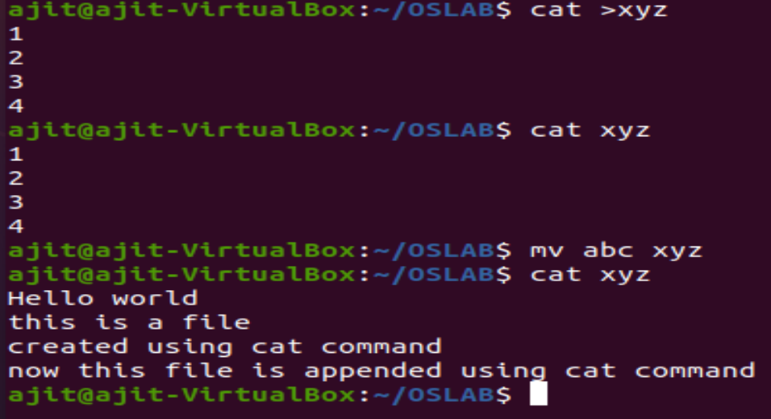

echo command

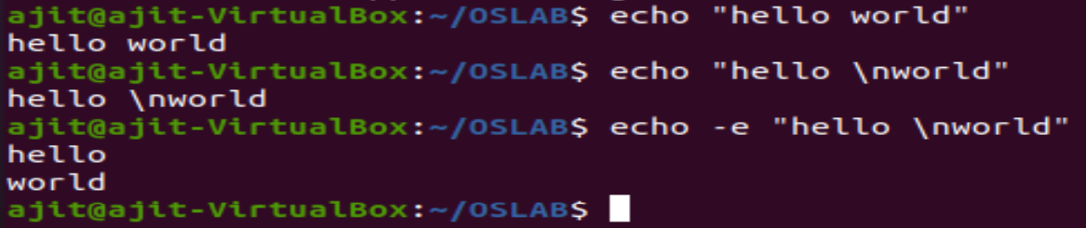

**Question 2:** 

**Answer:**

cut command

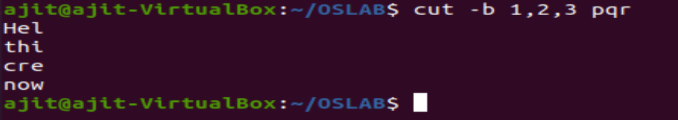

uniq command

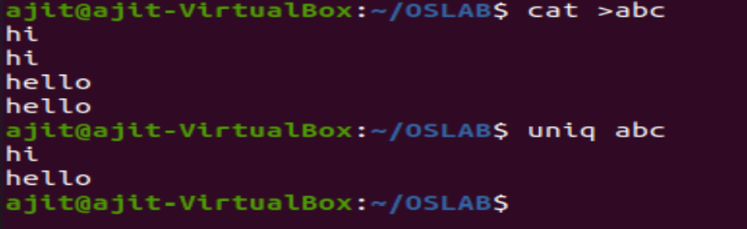

chmod command



sort command

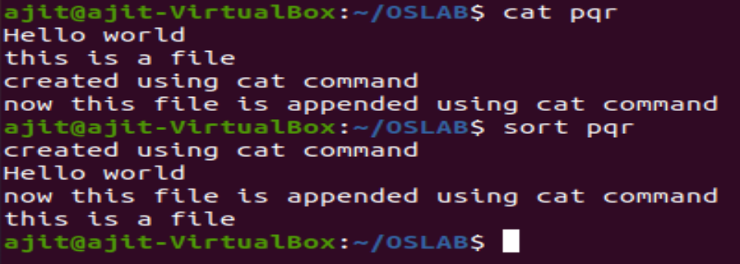

**Question 3:**



**Answer:**

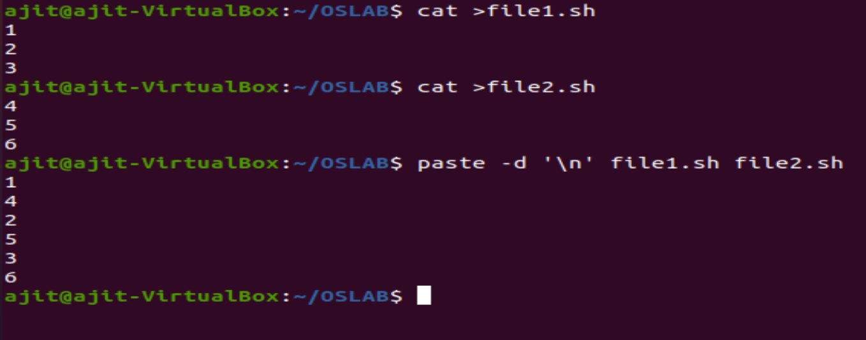

**Question 4:**

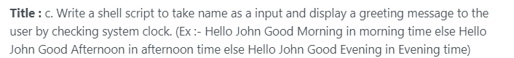

**Answer:**

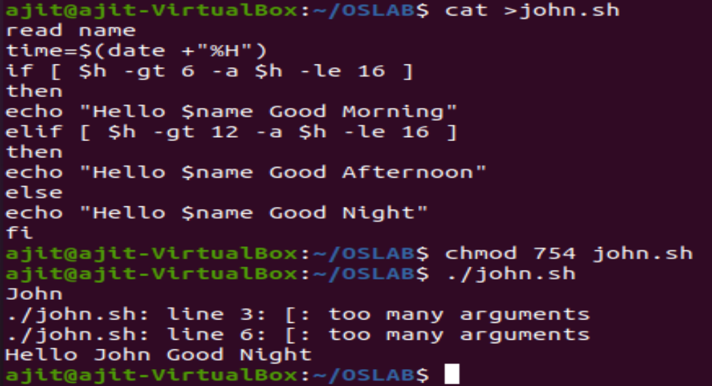

**Question 5:**



**Answer:**

